1. Project Introduction

The purpose underlying this project is to construct front-end drafts for the website of a recently open bookstore called “The Altria Family”. The bookstore constructed its brand image around traditional vintage books. The deliverables of this project include 5 html files, 5 JavaScript files, and 4 CSS files. The most important element of the project is JavaScript, which is behind much of the website’s interactivity. From this project, the developer was able to learn additional JavaScript DOM manipulation techniques and functions. Some noteworthy examples are how to apply JavaScript media query, how to retrieve CSS property from CSS files. The purpose of this report is to go over all the features used on the website and their mechanism. Short videos, which could be played by double clicking on them, have also been attached to aid the reader in the visualizing how certain elements interact with one another

1. Project Description
2. Required Features

Overall speaking, there are 4 fonts used on the website. Firstly, there is Times News Roman which could be seen used for normal texts and links. The font Playfair Display was used primarily for styling headings and titles. Less prevalent than the former 2 fonts are Roboto and Dancing Script, which were used mainly for numbers(price) and logo respectively. Out of the 4 fonts used, 2 of them were imported from Google Font (Roboto and Playfair Display) and the other 2 were native to the system. Text shadow was used exclusively to style the logo, and text underline was almost never used as underlining on the website was done mostly by adding border bottom. The website made limited and selective use of text colors, with some occasional golden and vintage yellow mixed with the more frequently used black and antique white.

In terms of containers, backgrounds were used prevalently on the website. Instead of using solely plain colors, the website made creative use of paper texture as backgrounds for the logo and the whole body. Only textures that do not hamper the users’ reading experience were chosen. In terms of element arrangement, the website used “display: grid” where there was a need for horizontally arranged, equally sized containers. Nevertheless, “display: flex” was preferred in most cases as it offers simpler transitioning from desktop devices (horizontally oriented screens) to mobile devices (vertically oriented screens). Dropdown mechanism was also implemented. The presence of collapsible contents is indicated by a dropdown arrow next to the heading. Lastly, in-body scroll bars are styled to match the size and the color of the container they are contained in.

When it comes to multimedia implementation, the website made ample use of images, with each of them being given an alt text. The video could be found at the end of the carousel in the homepage. While CSS animations are mostly absent, the website did make use of transitions for mouse-induced background color shifts. Transition could be seen slowing down the background color shift of the navigation elements on the header when the cursor hovers over them. Lastly, in terms of screen width responsiveness, the website was compatible, both visually and functionally, with screens as big as 2000px and as small as 350px. The design of the website followed the project specification closely. Nevertheless, the developers took the liberty and added some additional features, which will be present below. Before submission, the website had to undergo browser compatibility testing on both Chrome and Safari. As a result, the submitted website has no problems running on either browser.

1. Additional features

In terms of the header, the same design language for the header is shared across all pages. At screen size of 961px and above, the header is composed of a logo, and a fully visible navigation bar (id = “head_nav”) composed of 5 navigation links (class = “nav_item”), a search bar and 3 icons: the search icon, the user account icon, and the cart icon.

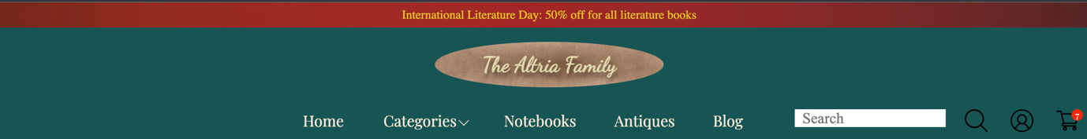

Header at screen width 961px and above

The search icon acts as a button that submit whatever the users input in the search bar to the system. The cart icon includes within it a small red container containing the number of items in cart. As it is now, the website allows the users to update the number of items in the cart by interacting with elements introduced below. The number within this small container will be consistent across the 4 pages, refreshing and switching between pages will not reset this number as it is saved to and taken directly from the local storage.

Hovering over these elements will brighten up their background and expand their size by 1.2 both horizontally and vertically. For the “Categories” navigation link in particular (id= “categorical”), a drop-down filter bar (id= “collapse”) will appear when it is hovered over. This drop-down menu allows user to quickly filter products by genre, which is further composed of many smaller subgenres, authors, the books’ countries of origin, and book formats. This mechanism was enabled by changing the display property of “collapse” from “none” to “grid” using JavaScript when the cursor is detected over the Categories navigation link. Its display property will only revert to “none” when the cursor is detected to have left its area.

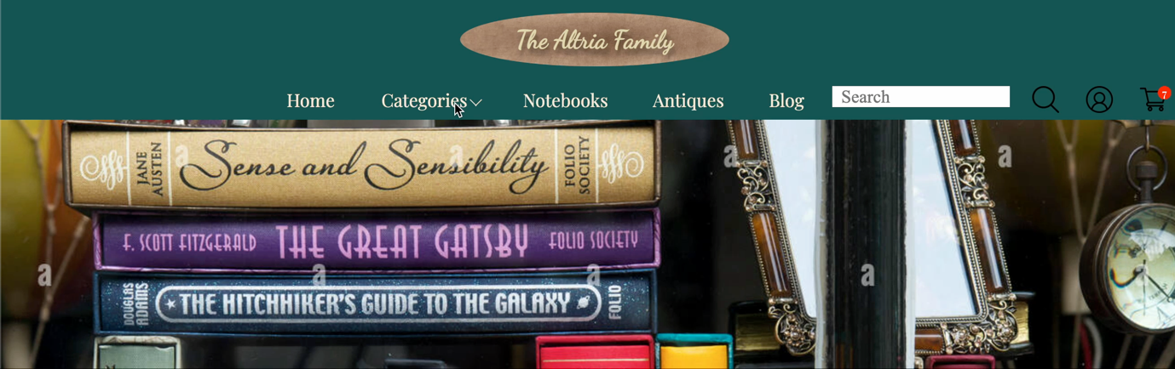

Video: Drop-down filter menu opened

When the screen width is between 960px and 700px, the display of the navigational bar “head_nav” will be switched to “none”. Next to the logo, a dropdown icon will appear, hovering on which will revert the display of the navigational bar back to “flex”. This time, the navigation bars will have the “flex-direction: column” property, which stack the navigational links on top of one another. The same mechanism will also apply here, hovering over the “Categories” navigation link will open a dropdown filter menu.

Navigation Bar at 960px screen width

When the screen width is below 700px, we apply a different mechanism to the dropdown filter as there is not enough horizontal space for the original mechanism will not work unless there is a horizontal scrollbar, which is detrimental to the experience of the users. In this screen width, hovering over “Categories” navigational link will open the filter menu within the same container (Originally, the filter menu is contained in a different container from the navigation bar). This is done by depositing additional HTML elements into the container of the “Categories” navigational link via JavaScript media query. This dropdown menu will initially contain only filter headings. Clicking on these filter headings will expand their containers and reveal their contents, which can be closed again with another click. The content of the dropdown filter menu are links that redirect users to the corresponding genre, author, format pages. Wherever the content is longer than its container, a customized vertical scroll bar will be applied. For most of the time, the logo will be anchored vertically and horizontally center within its container with its size unchanged. However, once the screen has shrunk below 500px, it will be anchored horizontally left and get smaller in size.

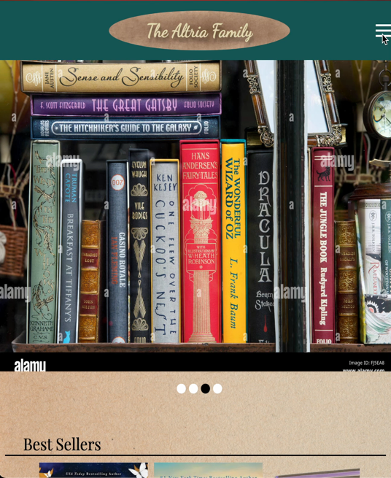

Video Navigation Bar and drop-down filter menu at below 500px screen width

One weakness of the current design is that the navigational bar and the logo container shares a single header. Specifically, it is good user experience design to have the main menu or navigational bar always accessible to the users without having to scroll back all the way to the top of the page. Doing so, however, would mean we will always have a large portion of the page unnecessarily occupied by the logo since with the current design, it is impossible to have the navigational bar follow the users as they scroll down without the logo container following them as well (Using position: fixed and top: 0). One solution for this is to have a separate header for the logo and a separate header for the navigational bar. We can then give the dropdown filter menu the “position: fixed” property, with the “top” property being the height of the navigational bar.

The design of the footer is relatively simpler than that of the header. It is composed of two containers arranged horizontally by the display flex property. The first container is a form that asks for users’ email to sign them up for Newsletter. The second component is a horizontal navigational bar that contains a series of link redirecting users to the About us, Contact us, FAQ pages.



Footer at screen width 961px and above

Like the header, the footer’s design is screen size responsive. When the width of the screen shrinks below 960px, the footer tag is given the “flex-direction: column” property, which re-arranges the two main components vertically. The elements within these 2 components are all anchored center vertically and horizontally with justify-center and align item.



Footer at screen width 960px and below

The main container of the homepage is composed of 4 components: the carousel, which will house special media such as videos and display announcements inside a textbox when the site is up and running; 2 horizontally scrollable containers that contain products’ images; and a container at the end that houses customers’ star rating and comments.

When it comes to the carousel, Javascript was the primary instrument. While CSS “scroll_behavior: smooth” could have been used to create a smoother transitioning, prior experiments have showed that the method does not allow for optimal user experience as clicking on the transitioning links (The 4 dots below the container) would cause the whole page to reposition. To create this carousel, two JavaScript arrays were created: an array containing the relative address to each image, and an array containing the class names of the four transitioning links. Clicking on a transitioning link will prompt the carousel container to adopt the correspondingly indexed image as its background. In this implementation, the video could be reached by clicking the fourth transitioning link.



Video: Carousel and the 4 navigational links

For the items’ containers, depending on the number of products we want to place inside them, horizontal scrolling might be inevitable. Hovering on the image of each product will reveal the “Add to cart” button, which has been hidden by the “display: none” property. By clicking on this button, users could update the number in the cart icon. Each of these images is a link redirecting the users to the corresponding book detail page. We implemented the “click-prompted scrolling” mechanism whereby users could scroll horizontally by clicking on either of the two adjacent arrows.

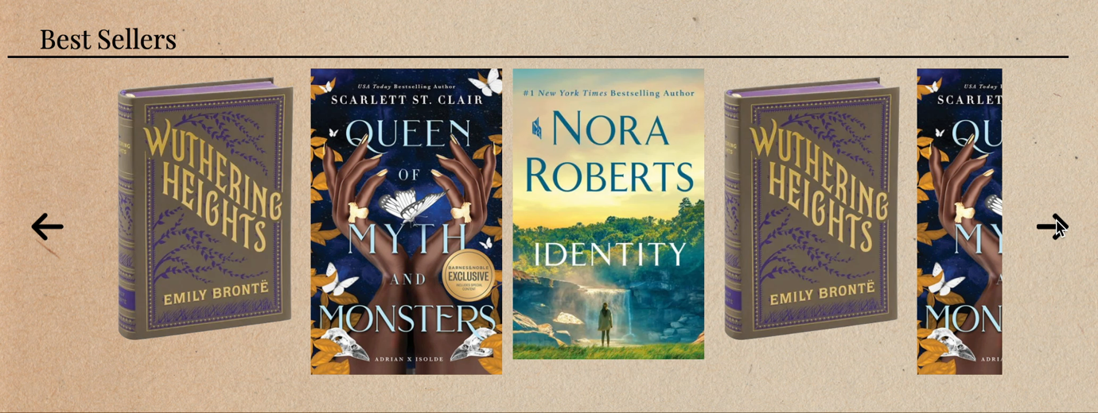

Video: Items Container with the scrolling arrows

When the screen has shrunk down below 500px in width, the 2 arrows will disappear and get replaced by a horizontal scroll bar. Users could scroll in the conventional way by swiping their fingers leftwards or rightwards. The rationale underlying this design decision is that on desktop devices users will typically have to hold and drag the scroll thump rightwards or leftwards to scroll horizontally. This means the scroll bar would need to be present on the screen all the time wherever there is scrollable content, which is not visually appealing. Hence, the two scrolling arrows were implemented to replace the less visually appealing horizontal scroll bar. On the other hand, since scrolling is done primarily through swiping gestures, the two scrolling arrows are no longer needed as they are counterintuitive and can take up screen real estate.

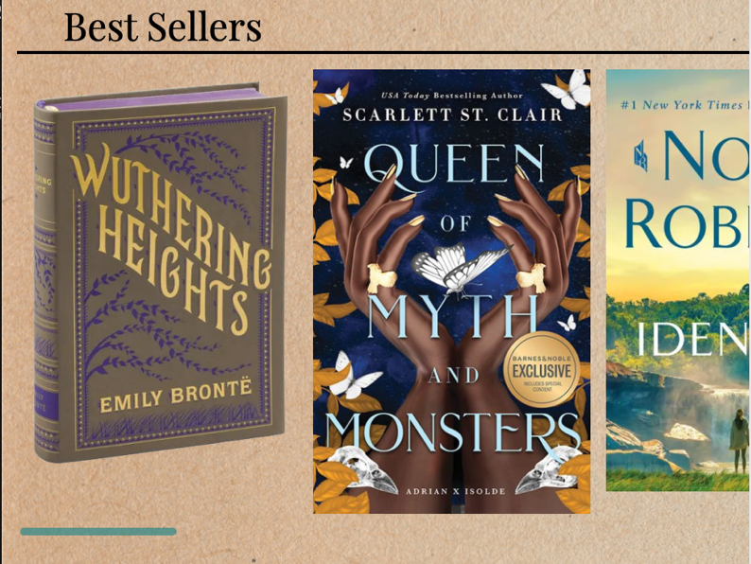

Items’ container at screen width 700px and below

This mechanism is only possible via CSS’ scroll snap type property and JavaScript’s scroll by function. The current design could be further improved by implementing the scroll loop mechanism. Moreover, as it is now, the scrolling speed is quite slow as the design only allows users to go through one item per click. This might be detrimental to user experience where there are lots of scrollable contents.

The last component of the homepage is that the customers’ ratings and comments container. The container is divided into 2 parts: the rating part which contains users’ name and their star-rating, and the comment part houses their corresponding comments. The 2 components are arranged horizontally for screen size above 700px. They will stack on top of one another once the screen width reaches 500px.

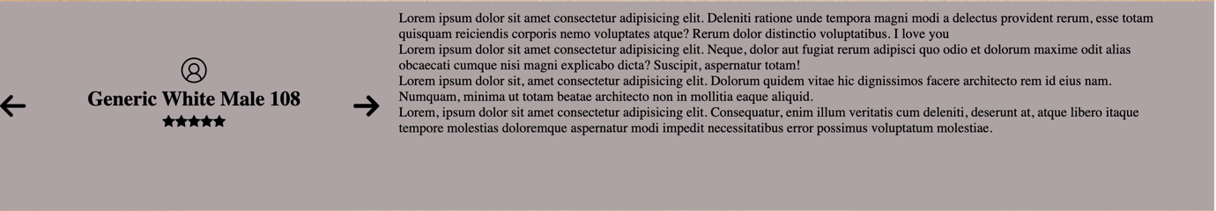

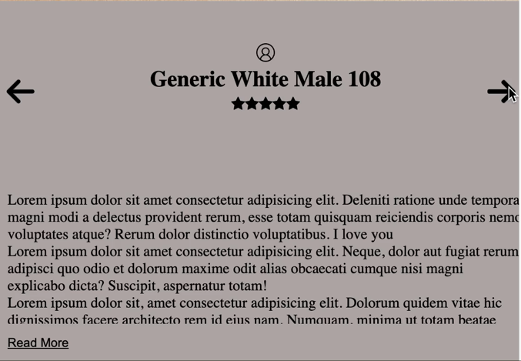

Customer’s ratings and comments at desktop screen (above) and screen width 700px and below (left video)

The same horizontal scrolling mechanism could be seen applied in this container with one key difference. Specifically, a click on an arrow here will prompt both sub-components to move to match the raters with their respective comments. For this container, JavaScript will continuously read the heights of each individual comments and compare them with the container’s height as the screen width changes. Where the height of a comment exceeds the height of the container, JavaScript will reveal the “read more” button, clicking on which will expand the overall height of the container to fit the comment. When the container is expanded, the “read more” button will be converted to the “read less” button, clicking on which will undo the previous effect and revert the container back to its original height.

Since the elements of the two category pages have been discussed above, they will not be touched upon by this report. The main container of the book detail page is composed of two components: a small container on top that house page directory; the bigger component in the middle housing the main content of the page. Within this component, there are two segments: a segment whose id is “selection” houses products’ images, titles, stock condition, prices, and buttons; and a segment housing the description of the product. It is the former segment that will be the primary subject of interest. Specifically, the “selection” segment was given the “display: flex” property, and its two immediate child components are arranged horizontally when the screen width is above 960px.

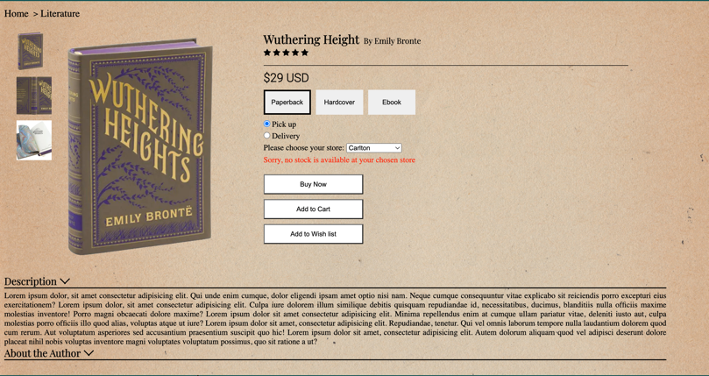

Product Page at screen width 960px and above

Below 960px, the “selection” container will have the “flex-direction: column” property, thus its child components are stacked on top of one another. The first child component, given the id “image selection”, is positioned on the left (or on top on Mobile devices) houses a big image on whose left there are three other smaller images. As per the project guideline, the three smaller images are arranged horizontally underneath the bigger one by giving the container of all four images the “flex-direction: column reverse” property. With JavaScript, users could choose which image to be displayed as the big image by clicking on any of the 3 smaller ones. The mechanism behind this is quite simple. First, a JavaScript array was created containing the relative address of the three images. When a user clicks on an image on the page, a function will be called, which will set the correspondingly indexed link as the “src” attribute of the big image tag.

The second immediate child of the “selection” container was given the id of “feature_selection”. This child container is composed of 4 components arranged vertically. The first component (id=book title) contains the name of the book, the author, and the star-rating given by customers. The second component (id=price_format) contains the book’s price information and available formats in the form of buttons. With the help of JavaScript, the price of the book could be changed depending on which format button is clicked. Clicking on a format button will give it a black and 2px thick border. The third component (id=check_availability) contains 2 radio button: “Pick up” and “Delivery”. If “Pick up” is checked, a third component will be revealed, which is a store selection list. Depending on which store the user chooses, the message displayed underneath. For instance, choosing “Carlton” will lead to the message being displayed as “Sorry, no stock is available at you’re your chosen store”. On the other hand, choosing “Frankston” will display the message as “The item is in stock”. If the radio “Delivery” is checked, the selection list will not be displayed. Lastly, there will be 3 buttons: Buy now, Add to Cart, and Add to Wish list, hovering on them will change their background color. Clicking on the “Add to Cart” button will also update the cart icon on the header

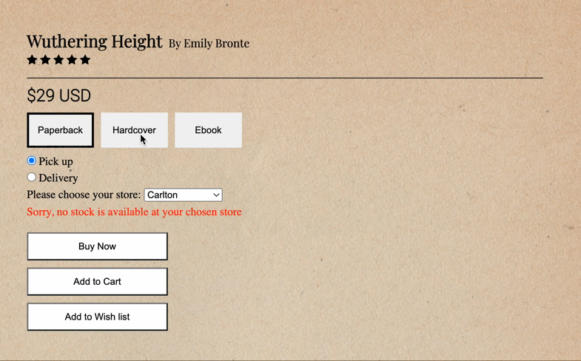

Video: Book’s title, author, customers’ ratings, format, availability, purchasing buttons

Lastly, the Description section (id=Description_Author) is composed of a container housing book description (id=Book_Description), and another container housing the author’s description (id=Author_Description). As deductible from the dropdown arrow adjacent to their respective headings, both articles are collapsible. While the Book_Description container is open by default, user could close it or open the Author_Description container by clicking on their headings. This helps minimizing the need for users to scroll through contents they consider unnecessary.

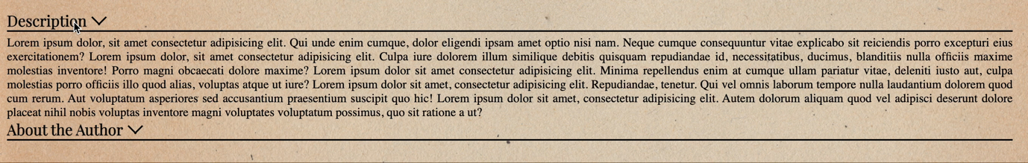

Video: Book’s and author’s collapsible description

1. Conclusion

Conclusively speaking, the developer was able to deliver more than what requested by the project scope. The final products are highly interactive web templates that closely mirror online bookstores such as Barnes and Nobles. Nevertheless, the development process was not without issues. The most prevalent problems are the lack of comments and unplanned elements naming, which made debugging difficult as it was hard to trace the source of errors among hundreds of code lines.